AIRO Prototype

# dEMONSTRATION AIRO PROTOTYPE

The purpose of this document is to document the prototype of the proposed AIRO application. The best way to view this demonstration is by using Chrome. Please not this is a prototype and not a working production application.

## Logging in

The URL for the AIRO demonstration is <https://dppdev1.alpa.org/AIRODev>.



For the prototype, the **log in functionality does not work**. This requires further discussion and was not part of the purpose of this prototype.

The below image is the home page for the AIRO application. It can be an area that could contain

1. Announcements
2. Additional information concerning the website
3. Whatever the owner of the AIRO application wants. This can be maintained by the owner as well. This requires further discussion.

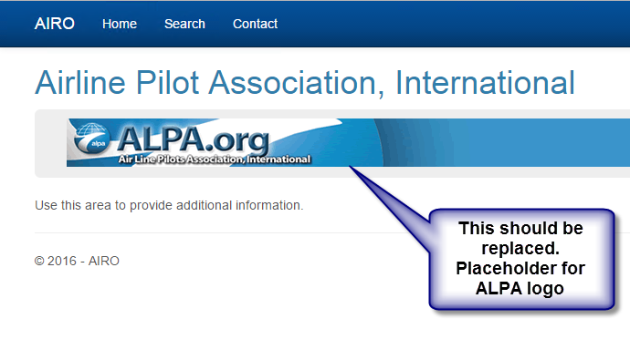

## Search functionality

Click the Search button and the next image will display.

The radio buttons have been removed. The vision is that the user can search from any of the fields.

Only the last name and ALPA number search fields are demonstrated during this prototype.

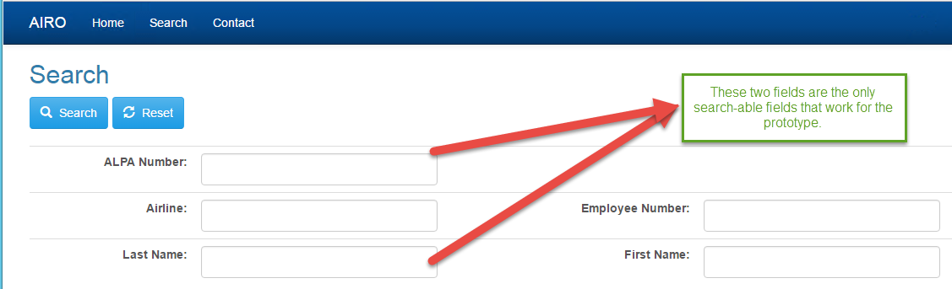

For this demonstration, enter a last name for searching (Douglas). Then click the search button. The next image will be displayed.

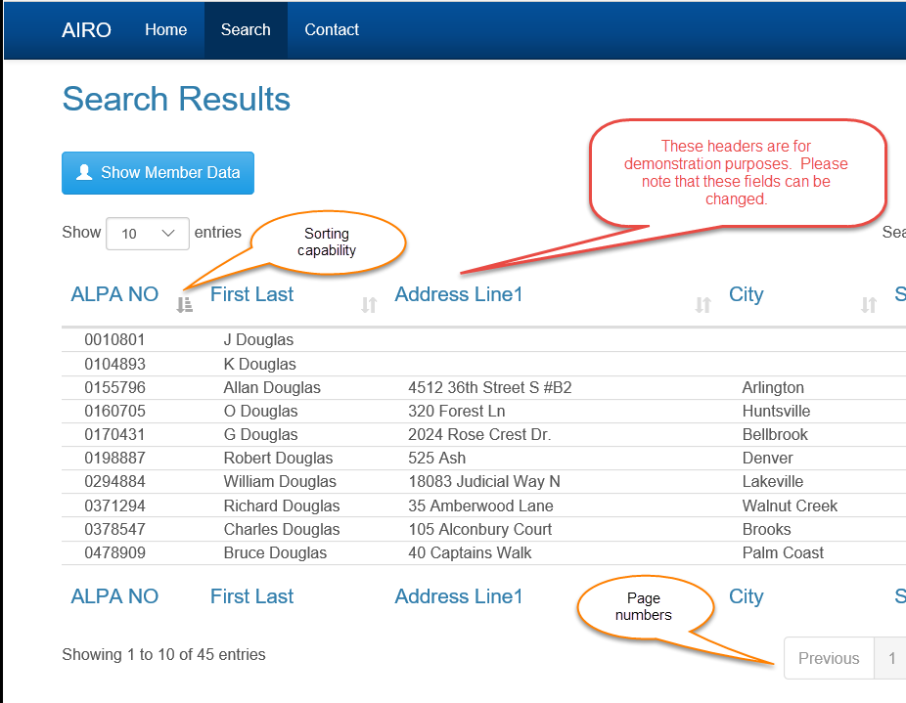

Note there is a Search text field on the right side.

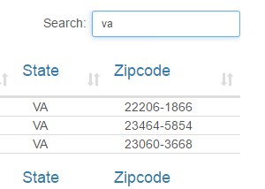

This can be used by any of the fields. In the above example **VA** is used to show only results in Virginia.

Next highlight a row and click the button to display the member’s data.

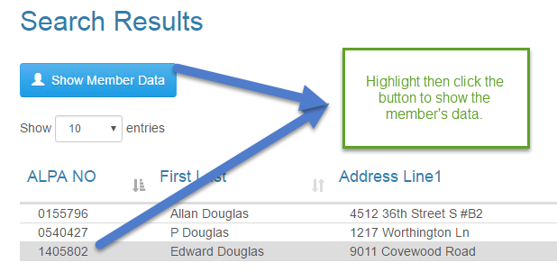

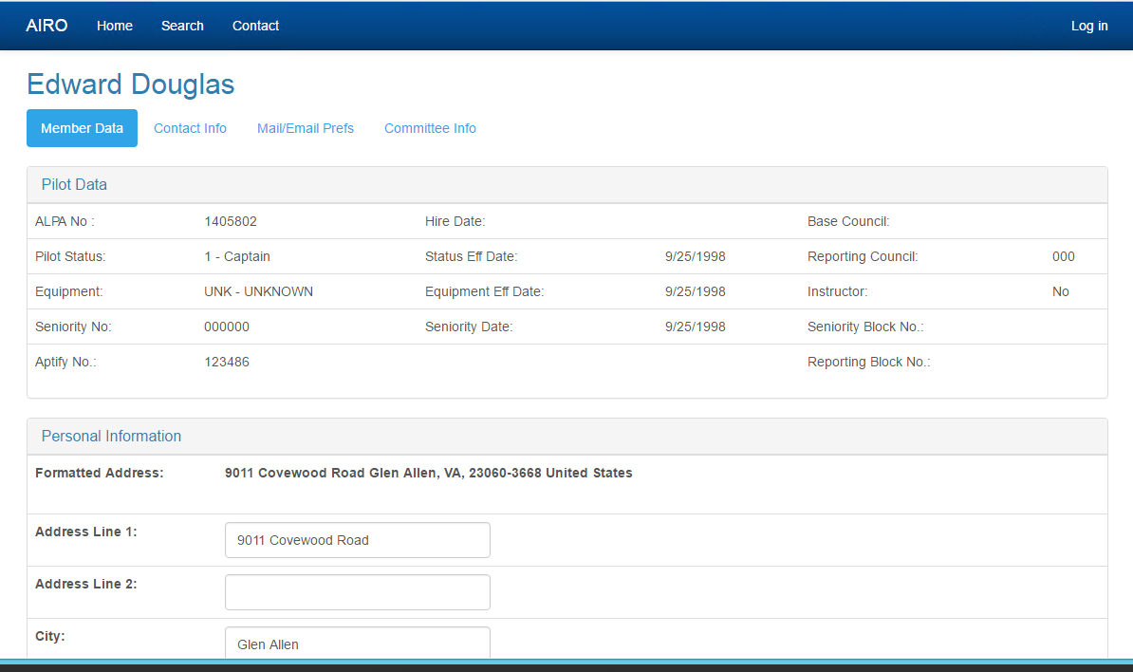

The UI is composed of tabs and accordions. The only editable pieces are the address fields.

